LAB TASK #2
Q1 Write a program that takes temperature in Fahrenheit from the user and converts it into Celsius using the formula: c= 5/9 (F-32)
Solution:
#include <iostream>
using namespace std;
int main()
{
cout << "Muhammad Salman/nSAP Id: 72373" << endl;
int F, C;
cout << "Enter temperature in Fahrenheit: " << endl;;
cin >> F;
C = (5 / 9) * (F - 32);
cout << "Temperature in Celsius:\n" << C << endl;
return 0;
}

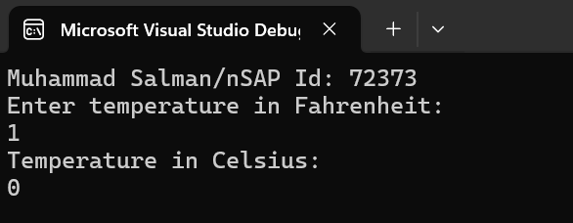

Q2 Write a program that calculates the volume of a cube by taking its measurements (length, width, and height) from the user. Formula : V = length * width * height
Solution:
#include <iostream>
using namespace std;
int main()
{
cout << "Muhammad Salman\nSAP Id: 72373" << endl;
int length, width, height, volume;
cout << "Enter length:\n ";
cin >> length;
cout << "Enter width:\n ";
cin >> width;
cout << "Enter height:\n ";
cin >> height;
volume = length * width * height;
cout << "Volume of the cube = \n" << volume << endl;
return 0;
}

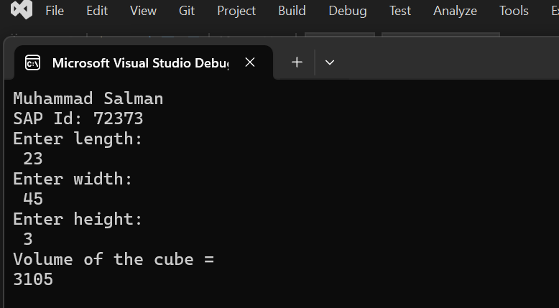

Q3: Write a program that takes marks obtained by a student in five subjects and calculates the total marks and percentage.
Solution:
#include<iostream>
using namespace std;
int main()
{
cout << "Muhammad Salman\nSAP Id:72373" << endl;
int DS, ICT, PF, ENG, ISL,obt,per;
cout << "Enter your Discrete Structure marks" << endl;
cin >> DS;
cout << "Enter your ICT marks" << endl;
cin >> ICT;
cout << "Enter your Programming Fundamentals marks" << endl;
cin >> PF;
cout << "Enter your ENG marks" << endl;
cin >> ENG;
cout << "Enter your ISl marks" << endl;
cin >> ISL;
obt = DS + ICT + PF + ENG + ISL;
cout << "Your obtained marks is:\n" << obt << endl;
per = obt * 100 / 500;
cout << "Your percentage is:\n" << per << endl;
return 0;
}

